**Balochistan:**

Hanna Lake

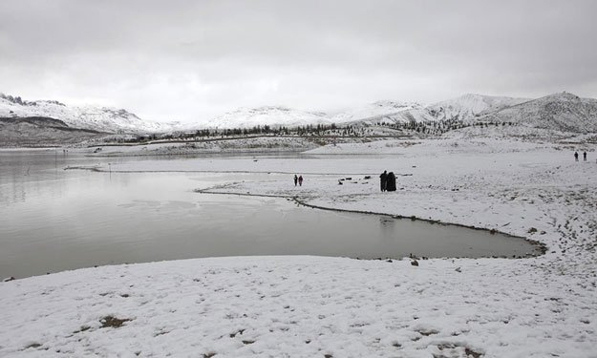

**Hanna Lake** is a lake in Urak Valley near Quetta city in Balochistan Province in southwestern Pakistan. It is surrounded by mountains. Hanna Lake is in the hills close to where the Urak Valley begins 17 kilometres (11 mi) east from Quetta city. The reservoir was constructed in 1894 during the British Colonial era on the land of local tribesmen, and is one of the main attractions in the city and a great historical bridge wall between two mountains the depths like battlements of a fort for storing of water. There is a lakeside restaurant with picnic tables shaded by pine trees at the end of the river where families can enjoy the food and weather on the eastern part the Hayat Durrani Water Sports Academy (HDWSA) the first and only rowing, canoeing, kayaking and sailing training and championships organising centre in Balochistan Province with provision of rough swimming facility. Hanna Lake is one of the most visited and accessible lakes in Balochistan.